Pretty Flowers
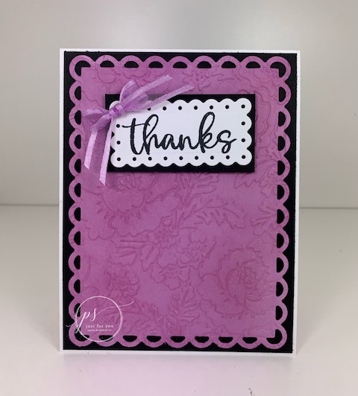
All images © 1990-2021 Stampin’ Up!®

Supplies:
- Stamp Sets – Biggest Wish (155052)
- Card Stock – Thick Basic White (159229), Basic White (159276), Basic Black (121045), Fresh Freesia (155613)
- Stamp Pads – Memento Tuxedo Black (132708), Fresh Freesia (155611)
- Misc. – Scalloped Contours Dies (155560), Pretty Flowers Folder (155428), Fresh Freesia Ribbon (155615), Stampin’ Dimensionals (104430); Stampin’ Seal Adhesive (152813); Die Cutting Machine (149653), Blending Brushes (153611), Mini Glue Dots (103683)

Measurements:
- Thick Basic White: 4 ¼” x 11” scored at 5 ½”
- Basic Black: 4 1/8” X 5 3/8”, 1 3/8” X 2 5/8”
- Basic White: 1 ½” X 2 ¾”
- Fresh Freesia: 4 ¼” x 5 ½”, 1 ½” X 4 ¼”

Instructions:
- Using the largest Scalloped Contour die; die cut the Fresh Freesia card stock.
- Emboss the Fresh Freesia card stock with the Pretty Flowers folder.
- Using the Blending Brushes and the Fresh Freesia ink; brush over the entire embossed piece; this will make the embossed image pop.
- Attach to the Basic Black card stock and attach to your card front.
- Using the smallest Scalloped Contour die; die cut the Basic White card stock.
- Stamp the Thanks using Black Memento ink.
- Attach to Basic Black card stock and pop it up on your card front using dimensionals.
- Tie a bow out of the Fresh Freesia Ribbon and attach as shown using mini glue dots.
- Emboss the Fresh Freesia card stock 1 ½” x 4 ¼” with the Pretty Flowers folder.
- Using the Blending Brushes and the Fresh Freesia ink; brush over the embossed piece.
- Attach to the inside bottom of your card.

