Sending Hugs
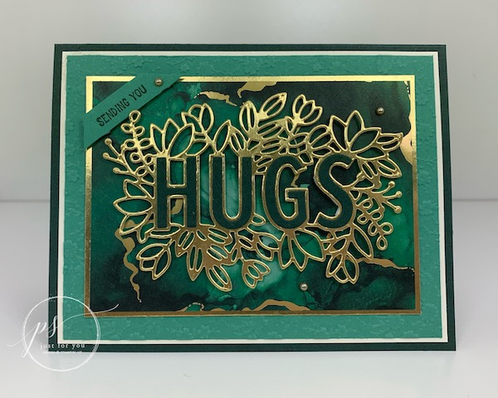
All images © 1990-2021 Stampin’ Up!®

Supplies:
- Stamp Sets – Sending Hugs Bundle (155859)
- Card Stock – Evening Evergreen (155574); Soft Succulent (155776); Very Vanilla (101650); Gold Foil Sheets (132622); Expressions In Ink Specialty Designer Series Paper (155464)
- Stamp Pads – Evening Evergreen (155576)
- Misc. – Ornate Floral 3D Embossing Folder (152725); Metallic Pearls (146282); Adhesive Sheets (152334); Mini Stampin’ Dimensionals (144108); Stampin’ Seal (152813); Stampin’ Cut & Emboss Machine (149653)

Measurements:
- Evening Evergreen: 5 ½” x 8 ½” scored at 4 ¼”, 1 ½” X 3 ½”
- Very Vanilla: (2) 4” X 5 ¼”
- Soft Succulent: 3 7/8” X 5 1/8”, 3/8” X 2 ½”
- Gold Foil: 3 ¼” X 4 ½”
- Expressions In Ink Specialty Designer Series Paper 3 1/8” X 4 3/8”, ¾” X 4”

Instructions:
- Fold your Evening Evergreen card base in half to create your card.
- Using Cut & Emboss Machine, emboss the Soft Succulent card stock using Ornate Floral Embossing Folder.
- Attach to the Very Vanilla card stock.
- Attach to your card front.
- Die cut out the center of the Gold Foil using the Hugs with Flowers die.
- Attach the Expressions In Ink Specialty Designer Series Paper to the Gold Foil.
- Attach a piece of Adhesive Sheet 1 ½” X 3 ½” to the Evening Evergreen card stock and die cut out the word Hugs.
- Attach the letters to the Gold Foil die cut piece.
- Pop up on your card front using Mini Stampin’ Dimensionals.
- On the strip of Soft Succulent card stock stamp the Sending You sentiment using Evening Evergreen ink.
- Pop up in the upper left hand corner as shown using Mini Stampin’ Dimensionals. Trim off the excess following the top and sides as shown.
- Attach Gold Metallic Pearls as shown.
- Attach the strip of Expressions In Ink Specialty Designer Series Paper to the left hand side of the Very Vanilla card stock. Attach to the inside of your card.

